The WCH Child Development Unit (CDU) is the central metropolitan DEVELOPMENTAL ASSESSMENT SERVICE for children with complex developmental concerns in three (3) or more areas. All referrals to the CDU must be completed using the CDU Referral Form.

We ask that when you complete this form you complete each section in its entirety. Each area has been included to aid in the triage process and avoid delays with processing.

Child’s Details
CHILD |  |  |  |  |  |  | WCH UR
Date of Birth | Click here to enter a date. |  |  |  | Gender | Click or tap here to enter text.
Child’s Address
Medicare No |  |  |  | Include Child’s ID Number
EXPIRY |  |  | Family do not have Medicare |  |  |  |  | ☐
Non-Medicare Families Please note that charges apply to services provided to patients who do not hold a Medicare Card. If the family does not have a Medicare Card, please contact the hospital’s finance team on 8161 7390 to discuss likely costs.

Parent/Guardian Details
Parent/Carer/Legal Guardian 1
RElationship to child
Address (if different from child’s)
Postal
Residential
Telephone
Parent/Carer/Legal Guardian 2
RElationship to child
Address (if different from child’s)
Postal
Residential
Telephone

Catchment Area
Acceptance of referrals is subject to catchment areas which are defined for the three assessment units. Please refer to the catchment map to determine which is the appropriate assessment unit to refer to (last page of this referral form). If you are unsure please call CDU if you are unsure.
Please do not refer to multiple units at once.
For children residing outside of the Adelaide metropolitan area, referrals will be reviewed taking into consideration child developmental assessment services available for the region.
☐ | SOUTH Flinders Medical Centre Child Assessment Team (8204 4433) Age Limit: up to 14 years
☐ | NORTH Gordon McKay Child Development Unit (7485 4109) Age Limit: up to 8 years
☐ | CENTRAL Women’s and Children’s Hospital Child Development Unit (8161 7287) Age Limit: up to 18

Who can refer to CDU?
PLEASE NOTE: If a child is referred by an allied health professional or educator, the CDU process can begin, however during the process if a paediatric appointment is required, the family will require a GP referral.
☐ | Medical Professionals (General Practitioners, Paediatricians, Medical Officers, Specialists)
☐ | Allied Health Professionals
☐ | Department for Child Protection
☐ | Early Learning/Preschool/Education  Referral must be via Leadership Team in consultation with Support Services e.g. Speech Pathology, Psychology or DECD Special Educator, Catholic Education / Association of Independent Schools SA Special Education Consultants/Advisors. Reports documenting this consultation must be provided** Documentation of this consultation process must be provided.  If assessments have been conducted copies must be attached before referral can be considered
REFERRER NAME |  |  |  | Date of Referral
Agency & Position |  |  |  |  | Telephone
Address
Email Address:
**MEDICAL PROFESSIONALS PLEASE SELECT ONE PAEDIATRICIAN**
NEXT AVAILABLE APPOINTMENTS ARE ALLOCATED
Dear Dr |  | ☐ JEYASEELAN (MUH) ☐ TIDEMANN ☐ WHITE ☐ NOZZA  ☐ BAULDERSTONE ☐ ROSSER ☐ LEE
SIGNATURE: |  |  |  | Provider No:
 |  |  |  | Referral Length:

Please confirm the following
☐Yes ☐No | Is Parent/Caregiver/Guardian aware of application?
☐Yes ☐N/A | Would Parent/Caregiver/Guardian like assistance to complete CDU Forms?
☐Yes ☐No | Does the child identify as Aboriginal/Torres Strait Islander
☐Yes ☐No ☐N/A | Is this child under Guardianship of the Chief Executive?
If YES please provide Dept for Child Protection Caseworker name & office in Parent/Guardian section
☐Yes ☐No | Has the child had a Comprehensive Health & Development Assessment
☐Yes ☐No ☐N/A | Is there a Family Court Order in Place? Is Yes, a copy must be attached.
☐Yes ☐No ☐N/A | Is an Interpreter Required? If yes, please state language required below.
 | Language: |  | Click here to enter text.
☐Yes ☐No ☐Unsure |  | Is the child registered with NDIS?
☐Yes ☐No ☐Unsure |  | If yes, is the child receiving services via the NDIS?

Does the child meet our criteria of 3 or more areas of developmental concern?
CDU CRITERIA:
☐ | Fine motor problems (handwriting, cutting, manipulation and dexterity)
☐ | Gross motor problems (locomotor, ball skills, coordination, climbing, motor planning)
☐ | Speech and language problems (excluding stuttering)
☐ | Sensory processing issues (sensitivities or sensory seeking behaviours)
☐ | Socialisation problems (not relating to peers, poor play skills, poor non-verbal skills, conversation skills, reduced eye contact)
☐ | Behaviours as listed
☐ | Repetitive behaviours/play, need for routines/rituals, obsessive interests. Inflexibility, unusual posturing of the body/movement patterns, unusual use of language
☐ | Children >5 years – inattentive, hyperactive, impulsive behaviours, poor planning and organisation
☐ | Self care skills (dressing, feeding self, toileting - excluding constipation)
☐ | Learning Difficulties (reading, spelling, maths or all)
FETAL ALCOHOL SPECTRUM DISORDER (FASD)
Fetal Alcohol Spectrum Disorder (FASD) is a term used for a spectrum of conditions caused by prenatal alcohol exposure.
Referrals for Fetal Alcohol Spectrum Disorder require the FASD Referral Appendix completed with this CDU Referral Form. This form can be obtained from our web page or contact our Unit to request the FASD Referral Appendix via Health.CDU@sa.gov.au
CDU DOES NOT ACCEPT REFERRALS FOR:
☐ | Residing outside of CDU catchment area (unless outside of accepted age range for catchment)
☐ | Single area of concern
☐ | Not on CDU referral form
☐ | Paediatric Management - Due to increased demand for assessments, the CDU does not have capacity to provide ongoing paediatric management.

Reason for referral to CDU?
☐ Comprehensive Developmental Assessment | ☐ Autism Spectrum Disorder | ☐ FASD
Summary of reason for referral to CDU
Click here to enter text.

Details of assessments conducted by education
EDUCATION ASSESSMENTS | Contact | Assessment | Date
Leadership Team | ☐ Yes | ☐ Yes | Click here to enter a date.
Speech Pathology | ☐ Yes | ☐ Yes | Click here to enter a date.
Psychology | ☐ Yes | ☐ Yes | Click here to enter a date.
Special Educator | ☐ Yes | ☐ Yes | Click here to enter a date.

Details of previous assessments
Eg. Psychology, Speech Pathology, Physiotherapy, Occupational Therapy, Autism Diagnostic assessment
Please attach copies if you have
Click here to enter text.

Details of current services
PROFESSIONAL | Name
☐ Paediatrician/Medical Specialist | Click here to enter text.
☐ Speech Pathologist | Click here to enter text.
☐ Occupational Therapist | Click here to enter text.
☐ Physiotherapist | Click here to enter text.
☐ Psychologist | Click here to enter text.
☐ Audiologist (Hearing) | Click here to enter text.
☐ Optometrist (Vision) | Click here to enter text.
☐ Other: (please state) | Click here to enter text.
☐ Other: (please state) | Click here to enter text.

Describe any difficulties the child is having in the following areas…
Language understanding or use:
Click here to enter text.
Fine motor skills, including handwriting:
Click here to enter text.
Gross motor skills (eg. balance, coordination):
Click here to enter text.
Sensory processing/responses:
Click here to enter text.
Self-help skills:
Click here to enter text.
Social skills:
Click here to enter text.
Making or keeping friends:
Click here to enter text.
Behaviour:
Click here to enter text.
Emotional Regulation:
Click here to enter text.
Using or understanding gestures or body language:
Click here to enter text.
Intense or unusual interests:
Click here to enter text.
Coping with changes
Click here to enter text.
Learning new skills/concepts:
Click here to enter text.
School progress:
Click here to enter text.
Attention and concentration:
Click here to enter text.
General Health:
Click here to enter text.
Sleep:
Click here to enter text.
Diet:
Click here to enter text.
Other:
Click here to enter text.

For more information
Child Development Unit
Women’s and Children’s Hospital
72 King William Rd, North Adelaide SA 5006
Telephone (08) 8161 7287
Fax: (08) 8161 6099
Email: Health.CDU@sa.gov.au
Website: http://www.wch.sa.gov.au/services/az/other/allied/childdev/index.html

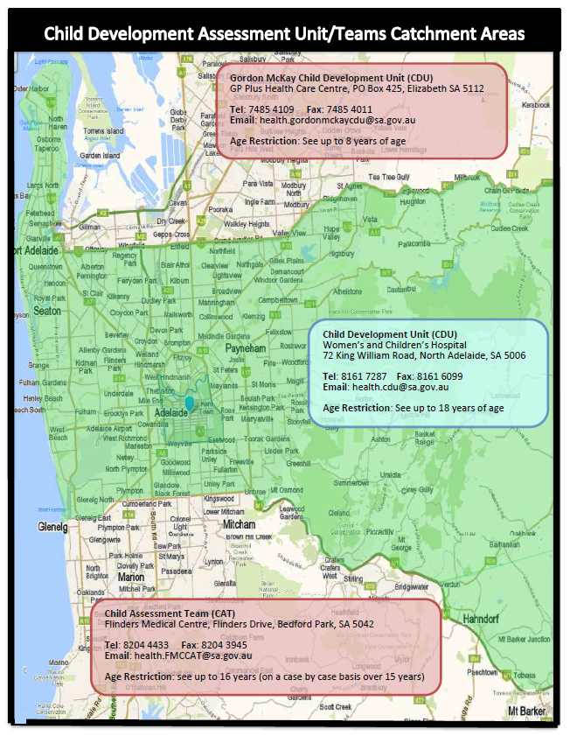
CDU Form Review Process | Updated: December 2021 Version 1.3 | Next Review:

